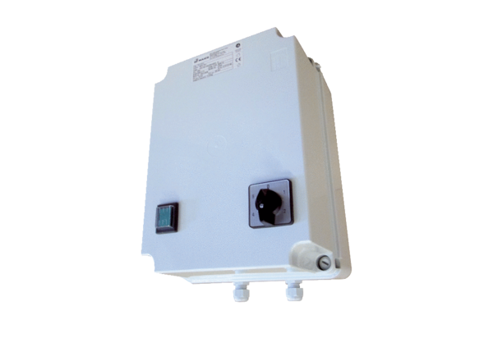5-step transformer TR 0,8-2Packing unit: 1 pieceRange: C
Article number: 0157.0148Manufacturer: MAICO

