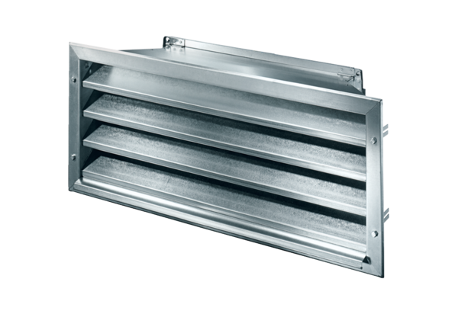External grille LZP-R 94Packing unit: 1 pieceRange: D
Article number: 0151.0389Manufacturer: MAICO

