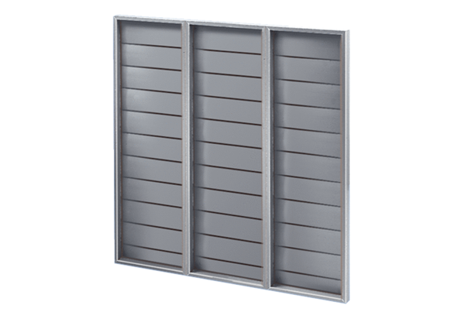Shutter ARP 100Packing unit: 1 pieceRange: C
Article number: 0151.0080Manufacturer: MAICO

