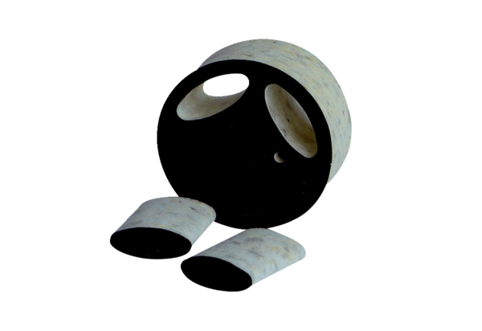Slide-in sound absorber SDE 10Packing unit: 1 pieceRange: C
Article number: 0044.0214Manufacturer: Jeven

