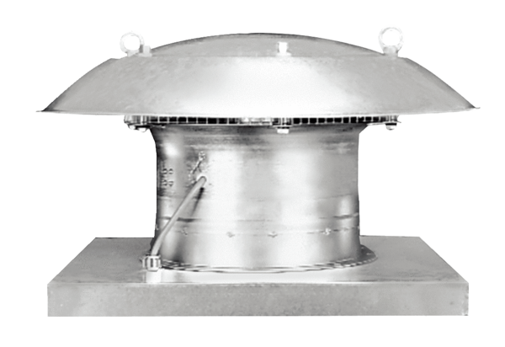Axial roof fan DZD 30/2 BPacking unit: 1 pieceRange: C
Article number: 0087.0216Manufacturer: MAICO

