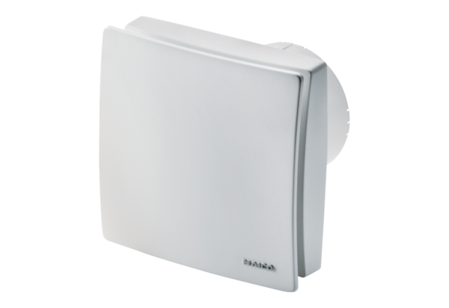Small room fan ECA 100 ipro HPacking unit: 1 pieceRange: A
Article number: 0084.0203Manufacturer: MAICO

