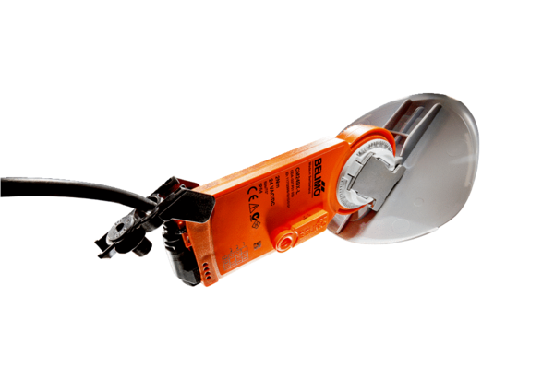Shutter drive with air damper MS 100 SPacking unit: 1 pieceRange: C
Article number: 0157.1235Manufacturer: MAICO

