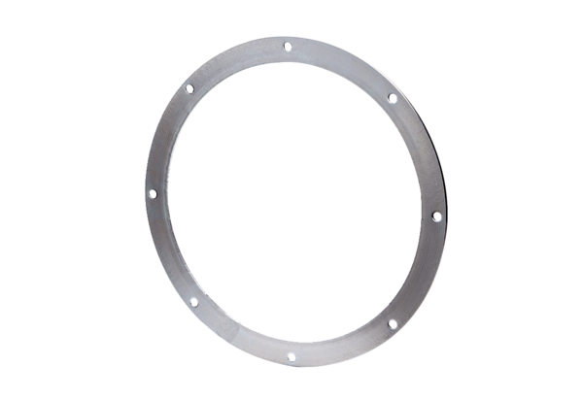Counter flange GF 30Packing unit: 1 pieceRange: C
Article number: 0056.0004Manufacturer: MAICO

