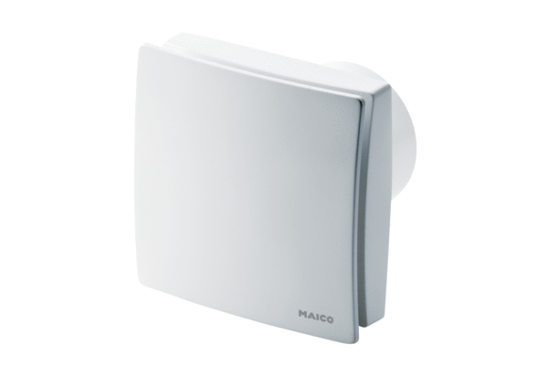Small room fan ECA 150 iproPacking unit: 1 pieceRange: A
Article number: 0084.0085Manufacturer: MAICO

