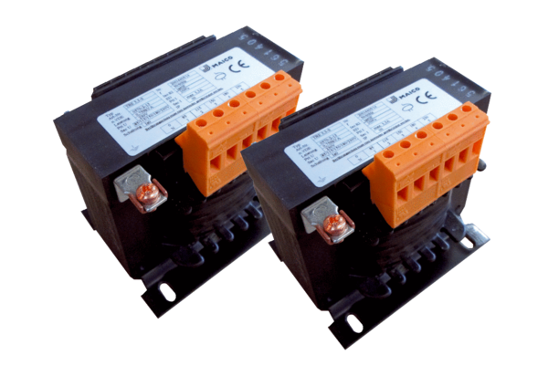5-step transformer, control cabinet TR 6,6 S-2Packing unit: 2 piecesRange: C
Article number: 0157.0153Manufacturer: MAICO

