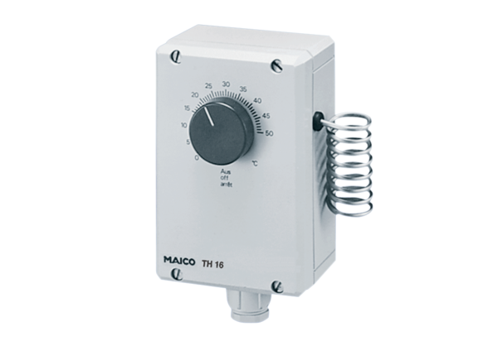Thermostat TH 16Packing unit: 1 pieceRange: C
Article number: 0157.0748Manufacturer: MAICO

