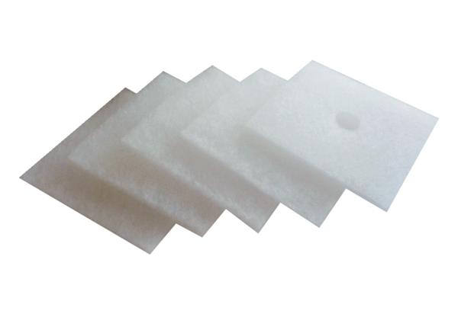Air filter, replacement ZF 60/100 bulk containerPacking unit: 100 piecesRange: B
Article number: 0093.0885Manufacturer: MAICO

