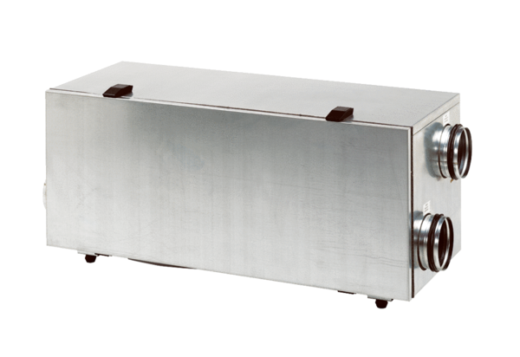Centralised ventilation unit WS 150 RPacking unit: 1 pieceRange: K
Article number: 0095.0057Manufacturer: MAICO

