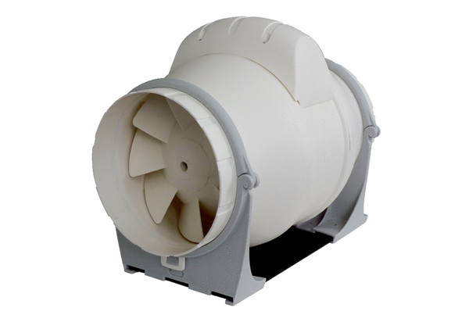Diagonal fan ERK 160Packing unit: 1 pieceRange: C
Article number: 0080.0180Manufacturer: MAICO

