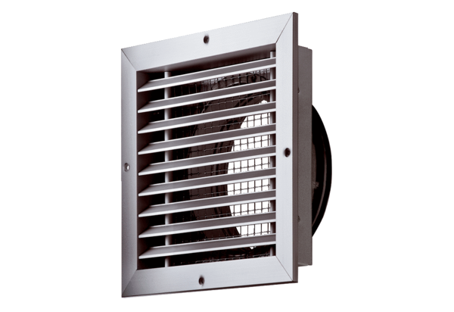External grille MGE 160 aluPacking unit: 1 pieceRange: K
Article number: 0078.0037Manufacturer: MAICO

