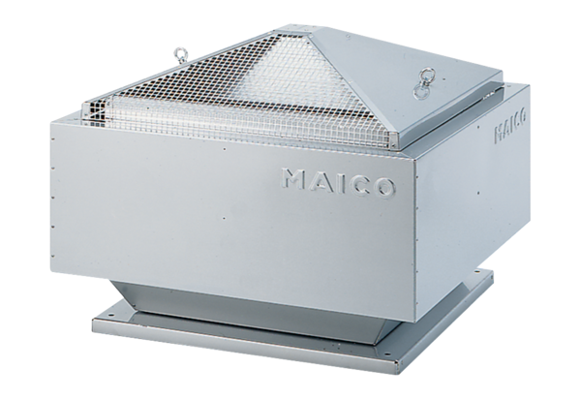Centrifugal roof fan DRD 31/6 BPacking unit: 1 pieceRange: C
Article number: 0087.0105Manufacturer: MAICO

