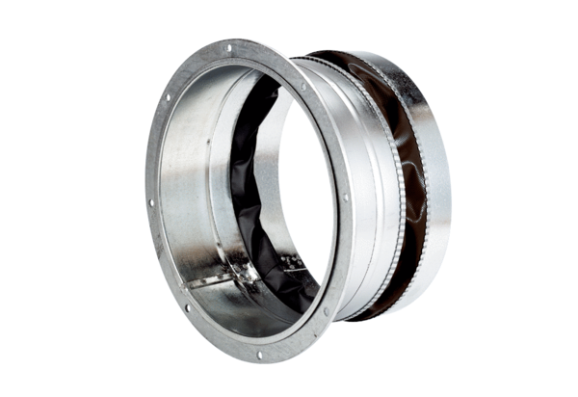Flexible coupling ELA 45 ExPacking unit: 1 pieceRange: C
Article number: 0092.0279Manufacturer: MAICO

