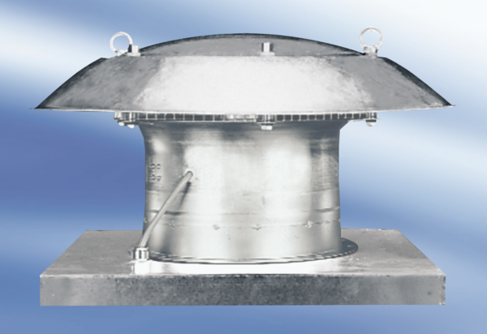Axial roof fan DZD 25/2 A-ExPacking unit: 1 pieceRange: C
Article number: 0087.0761Manufacturer: MAICO

