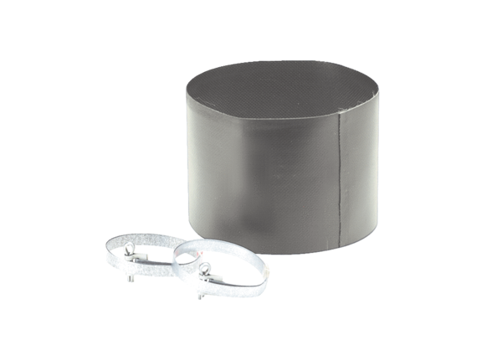Flexible cuff ELM 20Packing unit: 1 pieceRange: C
Article number: 0092.0118Manufacturer: MAICO

