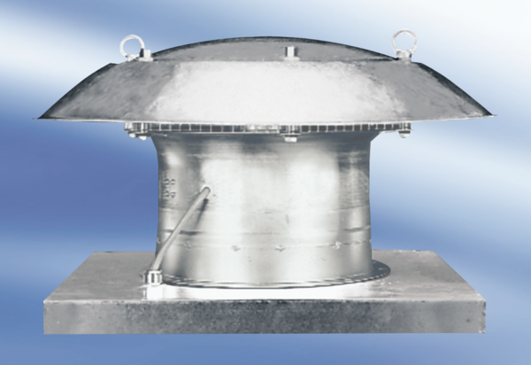Axial roof fan EZD30-2APacking unit: 1 pieceRange:
Article number: 0087.405Manufacturer: MAICO

