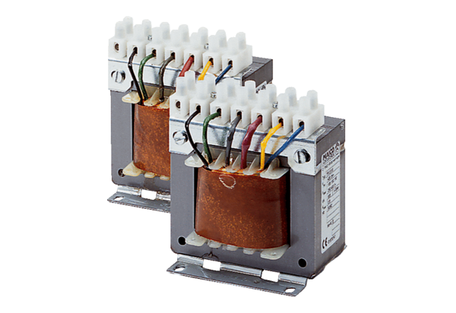5-step transformer, control cabinet TR 0,8 SPacking unit: 1 pieceRange: C
Article number: 0157.0741Manufacturer: MAICO

