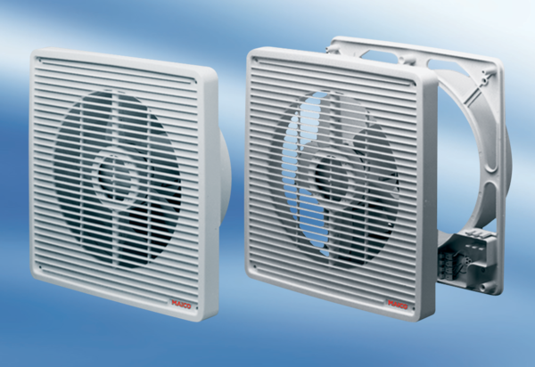Wall-mounted fan ETR 25Packing unit: 1 pieceRange: C
Article number: 0081.0505Manufacturer: MAICO

