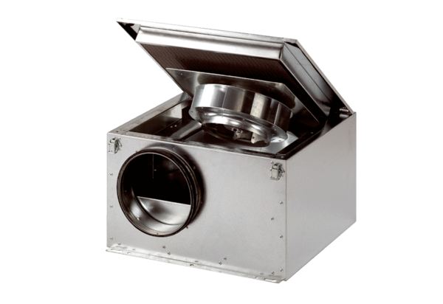Sound-insulated ventilation box ESR 16 SPacking unit: 1 pieceRange: C
Article number: 0080.0228Manufacturer: MAICO

