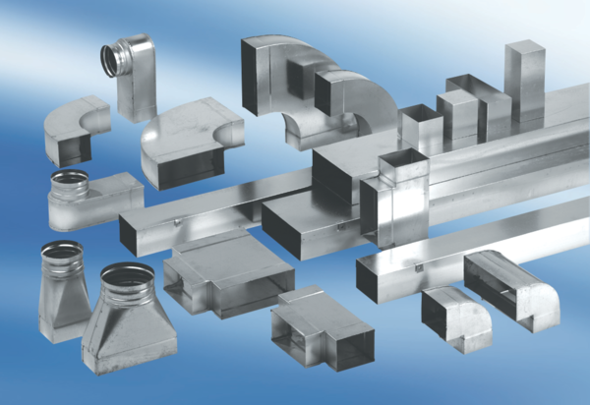40 mm channel sound absorbers with lining and attenuating linging KSDA80/150/700Packing unit: 1 pieceRange: K
Article number: 0092.0467Manufacturer: MAICO

