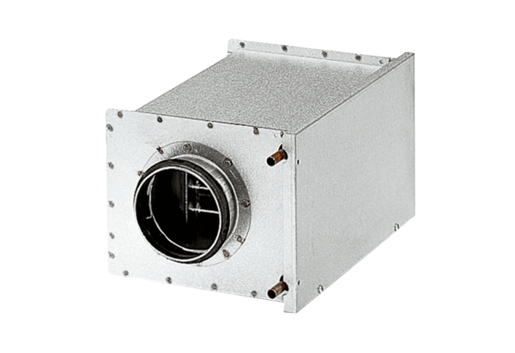Water air heater WRH 31-6Packing unit: 1 pieceRange: C
Article number: 0082.0121Manufacturer: MAICO

