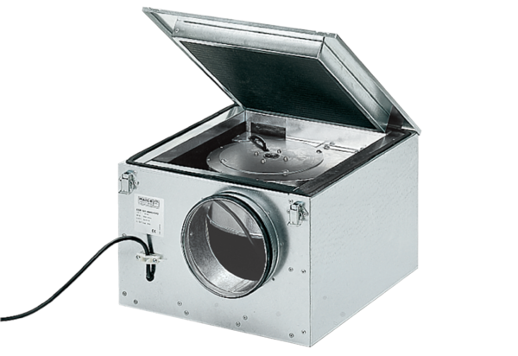Sound-insulated ventilation box ESR 16/1Packing unit: 1 pieceRange: C
Article number: 0080.0282Manufacturer: MAICO

