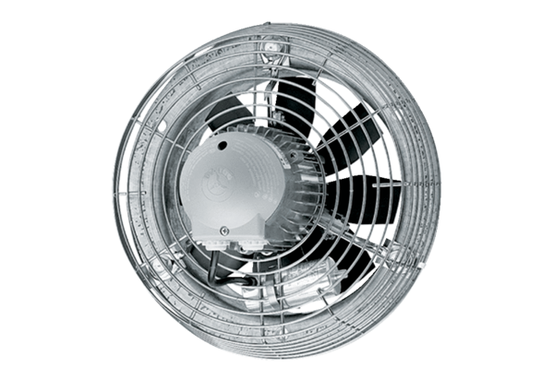Axial wall fan DZS 25/42 BPacking unit: 1 pieceRange: C
Article number: 0094.0041Manufacturer: MAICO

