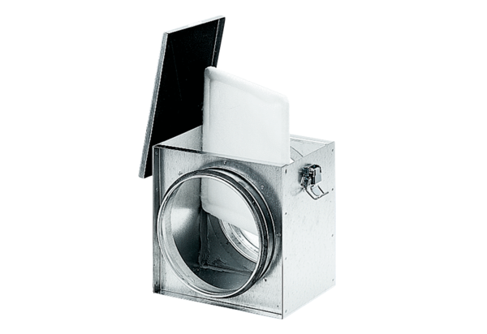Air filter TFE 16-4Packing unit: 1 pieceRange: C
Article number: 0149.0077Manufacturer: MAICO

