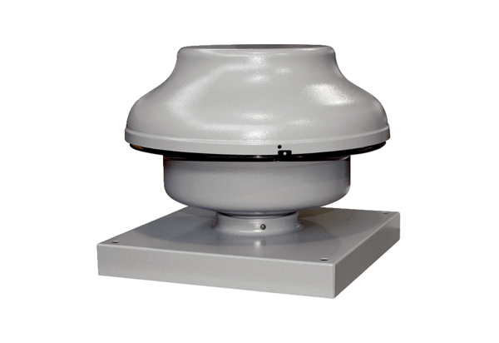Centrifugal roof fan EHD 20Packing unit: 1 pieceRange: C
Article number: 0087.0304Manufacturer: MAICO

