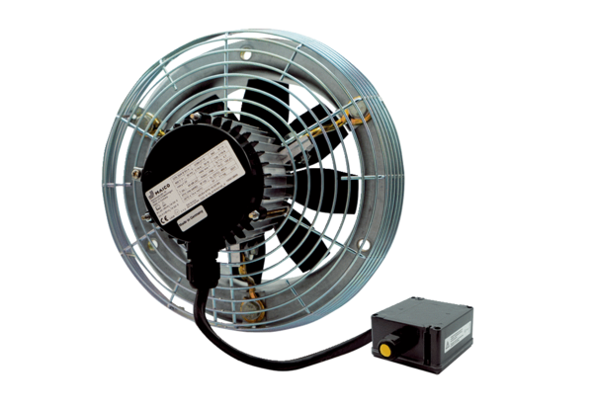Axial wall fan DZS 30/4 B Ex ePacking unit: 1 pieceRange: C
Article number: 0094.0121Manufacturer: MAICO

