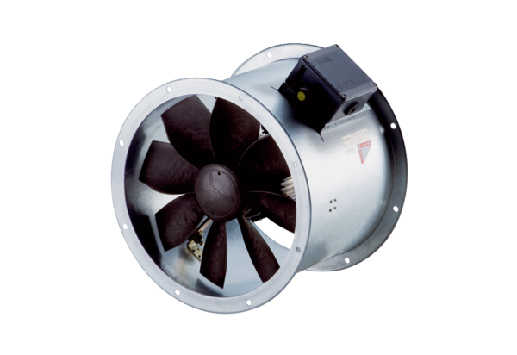Axial duct fan DZR 40/4 B Ex ePacking unit: 1 pieceRange: C
Article number: 0086.0710Manufacturer: MAICO

