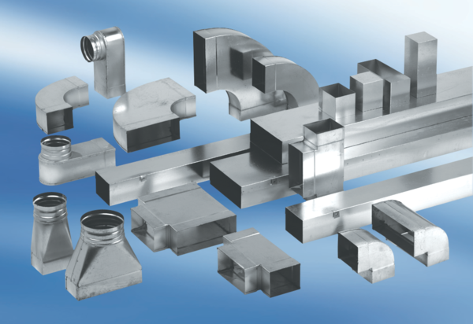Intermediate piece, asymmetric USAN55/220/100Packing unit: 1 pieceRange: K
Article number: 0055.0660Manufacturer: MAICO

