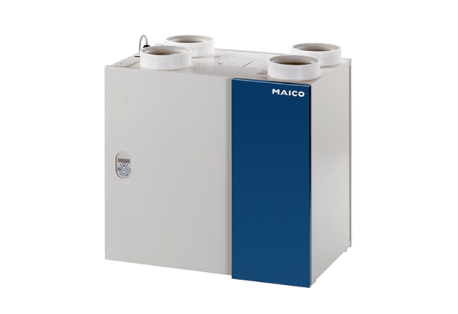Aeronom room air system WRG 400 ECPacking unit: 1 pieceRange: K
Article number: 0082.0061Manufacturer: MAICO

