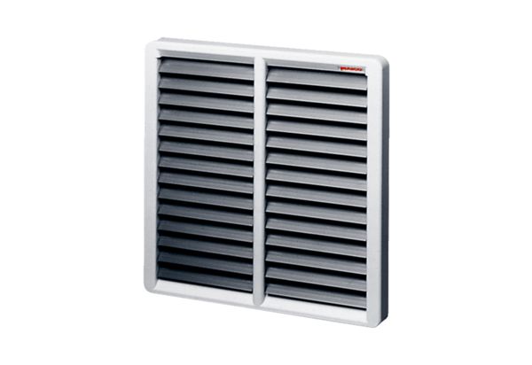Shutter AS 50Packing unit: 1 pieceRange: C
Article number: 0151.0336Manufacturer: MAICO

