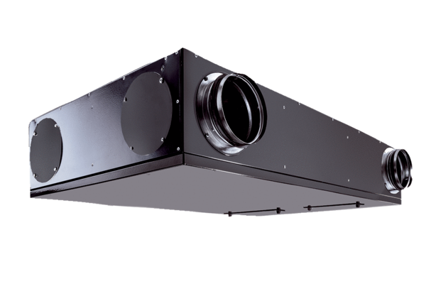Centralised ventilation unit Trio QZ-ALPacking unit: 1 pieceRange: K
Article number: 0095.0126Manufacturer: MAICO

