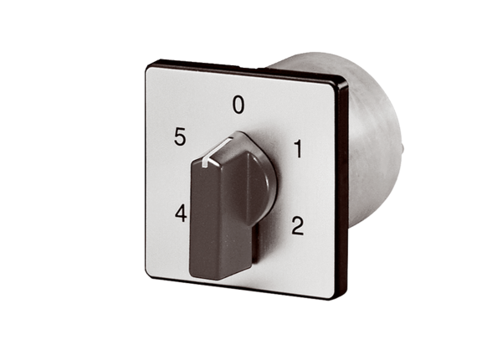5-step switch for TRE...S -2/ TR...S-2 5-step transformers ESS 20Packing unit: 1 pieceRange: C
Article number: 0157.0749Manufacturer: MAICO

