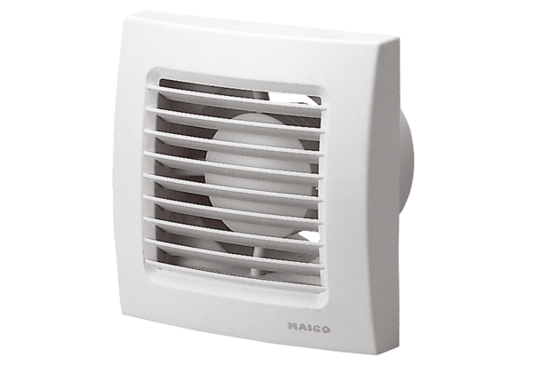Small room fan ECA 100 VZPacking unit: 1 pieceRange: A
Article number: 0084.0001Manufacturer: MAICO

