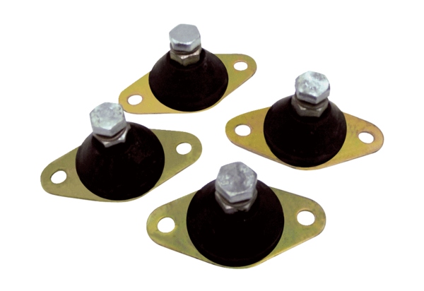Vibration damper GP 20Packing unit: 4 piecesRange: C
Article number: 0092.0152Manufacturer: MAICO

