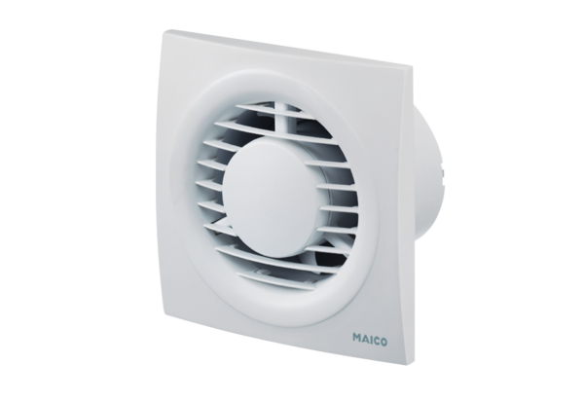Small room fan ECA piano TCPacking unit: 1 pieceRange: A
Article number: 0084.0081Manufacturer: MAICO

