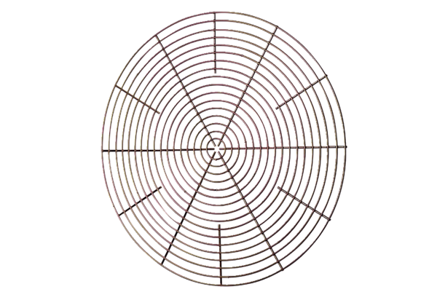Protective grille, metal SG 35Packing unit: 1 pieceRange: C
Article number: 0150.0117Manufacturer: MAICO

