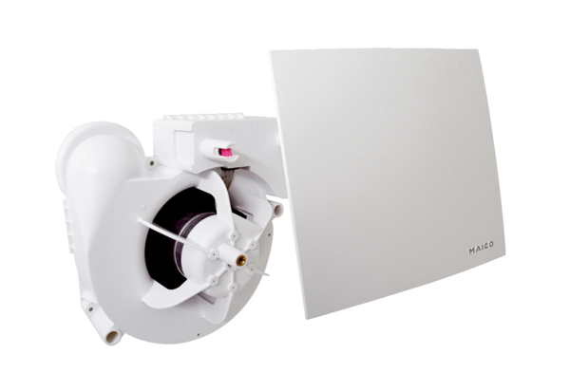Fan insert ER 60 EHPacking unit: 1 pieceRange:
Article number: 0084.0375Manufacturer: MAICO

