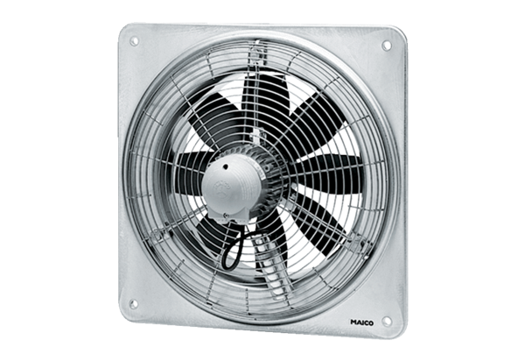Axial wall fan EZQ 25/4 DPacking unit: 1 pieceRange: C
Article number: 0083.0487Manufacturer: MAICO

