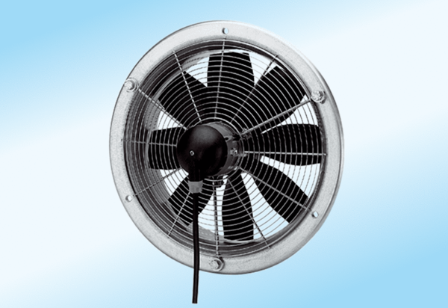Axial wall fan DZS 60/6 A-ExPacking unit: 1 pieceRange: C
Article number: 0094.0115Manufacturer: MAICO

