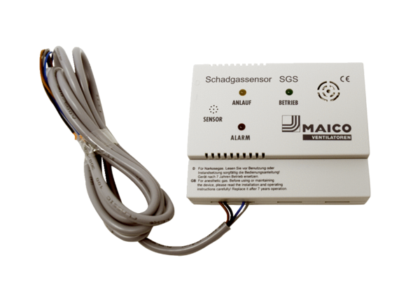harmful gas sensor SGSPacking unit: 1 pieceRange: K
Article number: 0093.1323Manufacturer: MAICO

