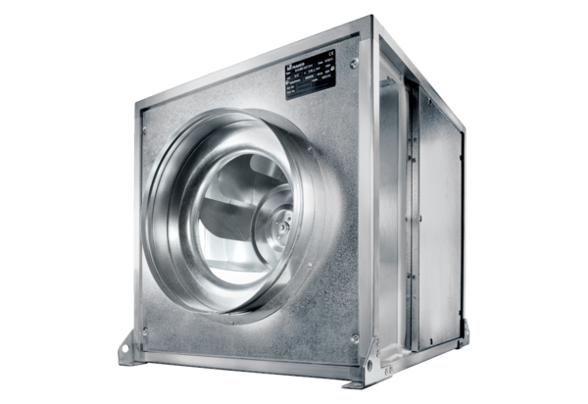Quickbox DSQ 25/4 KPacking unit: 1 pieceRange: C
Article number: 0080.0074Manufacturer: MAICO

