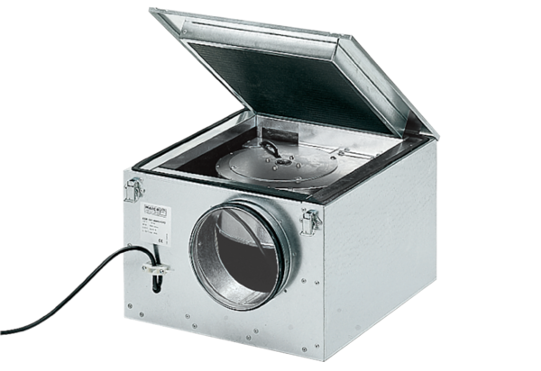Sound-insulated ventilation box ESR 25/1Packing unit: 1 pieceRange: C
Article number: 0080.0284Manufacturer: MAICO

