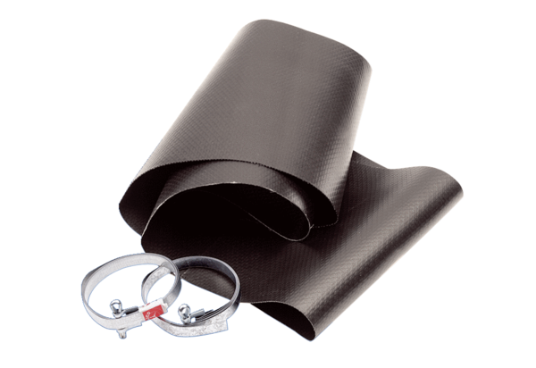Flexible cuff EL 35Packing unit: 1 pieceRange: C
Article number: 0092.0090Manufacturer: MAICO

