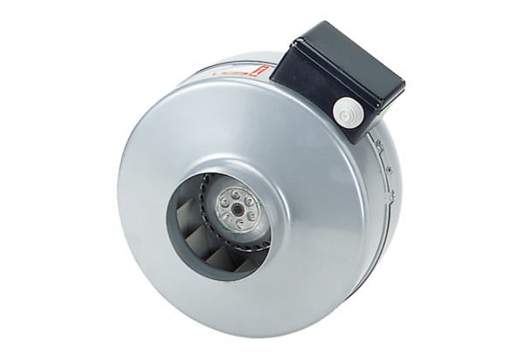Centrifugal duct fan ERR 31/1 SPacking unit: 1 pieceRange: C
Article number: 0080.0279Manufacturer: MAICO

