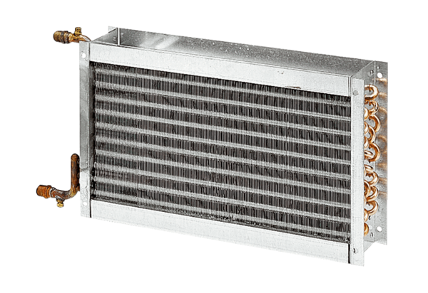Water air heater WHP 56-69Packing unit: 1 pieceRange: D
Article number: 0082.0124Manufacturer: MAICO

