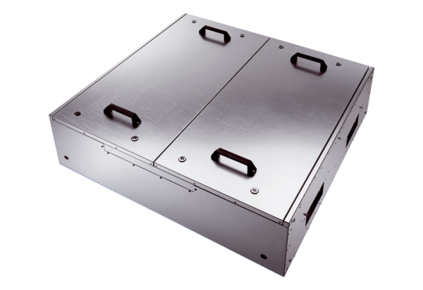Sound-insulated ventilation box KFR 6030-KPacking unit: 1 pieceRange: K
Article number: 0080.0966Manufacturer: MAICO

